AI Website Builder
A Major Project Report
Submitted by
[Student Name 1] - [Register Number 1]
[Student Name 2] - [Register Number 2]
[Student Name 3] - [Register Number 3]
In partial fulfilment for the award of the degree of
BACHELOR OF ENGINEERING
in
CSE
[College / Institution Name]
Guide: [Guide Name], [Guide Designation]
Academic Year: [Academic Year, e.g. 2025-2026]

BONAFIDE CERTIFICATE
[University Name]
Certified that this project report “AI Website Builder” is the bonafide work of
[Student Name 1] - [Register Number 1]
[Student Name 2] - [Register Number 2]
[Student Name 3] - [Register Number 3]
who carried out the project work under our supervision.

SIGNATURE | SIGNATURE
[Head of Department Name], [Qualification] | [Supervisor Name], [Qualification]
HEAD OF THE DEPARTMENT | SUPERVISOR
[Designation] | [Designation]
CSE | CSE
[College / Institution Name] | [College / Institution Name]
Submitted for viva voce held on [Date] at [College / Institution Name].

INTERNAL EXAMINER | EXTERNAL EXAMINER

ACKNOWLEDGEMENT
[A project of this scope would not have been possible without the guidance and support of many people. We express our sincere gratitude to [Management / Chairman Name], [Title], and [Director / Principal Name], [Title], for providing us with the infrastructure and academic environment needed to carry out this project.
We are especially thankful to [Head of Department Name], Head of the Department, CSE, for their constant encouragement throughout this project. We express our profound thanks to our project guide [Guide Name], [Designation], for their valuable guidance, suggestions, and support, which enabled us to complete this project successfully.
We also thank all the teaching and non-teaching staff of the CSE department for their support. Finally, we thank our families and friends for their encouragement throughout this endeavour.]

ABSTRACT
Building a professional website conventionally demands coding proficiency, design skill, time, and money, placing it out of reach for students, individuals, and small businesses who need an online presence but lack these resources; even existing website builders still require substantial manual template selection and layout editing, offering limited true automation. This project proposes a locally hosted AI Website Builder, implemented as a Python Flask web application, that allows a user to type a plain-English description of a desired website and receive a complete, themed, multi-section site in response. The core pipeline begins with lightweight natural-language preprocessing of the prompt, followed by two scikit-learn classifiers — a TF-IDF plus logistic-regression model that predicts the site type (portfolio, restaurant, small business, education, blog, or non-profit) and a one-vs-rest logistic-regression model that predicts the required sections. A rule-based slot extractor using regular expressions and word lists then pulls out the site name, tagline, contact details, and tone/color cues, which a theme engine maps to a matching palette and font stack. A component assembler combines the predicted sections with a mandatory navbar, hero, and footer, drawing content from a hand-built content bank, and a Jinja2-based renderer produces validated HTML/CSS/JavaScript that is shown in a live, device-width-togglable preview. The assembled project is persisted in SQLite and can be exported as a self-contained, dependency-free ZIP archive for fully offline use. An explicit low-confidence warning, based on prediction probability, vocabulary coverage, and prompt length, flags unreliable guesses to the user. The expected outcome is a working demonstration in which a short prompt such as “a bakery website called Sweet Crumbs” yields a responsive preview within milliseconds, together with measured accuracy and confidence figures shown on an About page.

Table of Contents
- Abstract
- List of Figures
- List of Tables
- List of Abbreviations
- Chapter 1 - Introduction
  - 1.1 Background of the Project
  - 1.2 Existing Method
  - 1.3 Proposed Method
  - 1.4 Methodology
  - 1.5 Objectives
- Chapter 2 - Literature Survey
- Chapter 3 - System Design
  - 3.1 System Architecture
  - 3.2 Functional Workflow
  - 3.3 Software Design
  - 3.4 Software Modules
  - 3.5 Technology Stack
  - 3.6 Hardware / Physical Components (Optional - hardware/IoT/embedded projects only)
  - 3.7 Summary
- Chapter 4 - Software Requirements
  - 4.1 Software Development Environment
  - 4.2 Tools Used
  - 4.3 Core Features
  - 4.4 Software Integration
  - 4.5 System Testing and Debugging
  - 4.6 Summary
- Chapter 5 - Result and Discussion
  - 5.1 Implementation Results
  - 5.2 Feature Performance
  - 5.3 Alert and Output Behaviour (Optional - projects with alerts/notifications only)
  - 5.4 Discussion
  - 5.5 Limitations
  - 5.6 Summary
- Chapter 6 - Conclusion and Future Enhancement
  - 6.1 Conclusion
  - 6.2 Future Enhancements
- References
- Appendix A - Screenshots
- Appendix B - Sample Test Cases (Optional)
- Appendix C - API / Dataset Details (Optional - AI/ML and IoT/hardware projects)
Mandatory vs. optional: every section above is required unless marked (Optional). Optional sections apply only to certain project types (e.g. hardware/IoT/embedded builds, or projects with alert/notification features) - remove them if they don’t apply to your project rather than leaving them blank.

List of Figures
[List every figure inserted throughout this document, e.g. “Figure 3.1: System Architecture Diagram … 12”, once page numbers exist. Populate this after you’ve added your actual diagrams/screenshots - do not leave figure numbers guessed here.]

List of Tables
[List every table inserted throughout this document, e.g. “Table 3.1: Technology Stack … 14”, once page numbers exist.]

List of Abbreviations
Abbreviation | Expansion
AI | Artificial Intelligence
NLP | Natural Language Processing
TF-IDF | Term Frequency-Inverse Document Frequency
HTML | HyperText Markup Language
CSS | Cascading Style Sheets
JS | JavaScript
SQLite | Structured Query Lite (a self-contained, serverless relational database engine)
ZIP | Zipped Archive File Format
GPU | Graphics Processing Unit
RL | Reinforcement Learning
UI | User Interface

CHAPTER 1 - INTRODUCTION

1.1 Background of the Project
A functional website remains one of the most effective ways for an individual, student, or small business to establish credibility and reach an audience, yet the barrier to creating one has stayed stubbornly high. Producing even a modest multi-page site traditionally requires familiarity with HTML structure, CSS layout rules, responsive design principles, and often a templating or scripting language, none of which a first-time founder, a freelance tutor, or a college club organizer can be expected to already know. Hiring a freelance developer or design agency to build a basic five-page site commonly costs anywhere from a few thousand to tens of thousands of rupees and takes days to weeks of back-and-forth revisions, a cost and timeline mismatch for someone who simply wants an online presence for a bakery, a tuition service, or a personal portfolio. The result is a large population of potential site owners who either go without a website entirely or settle for an unpolished, generic placeholder page that undersells their actual offering.
Beyond the raw skill barrier, the time cost of manual website creation compounds quickly once a user factors in content writing, section ordering, color and font selection, and cross-device testing. A non-technical user who does attempt a do-it-yourself build using raw HTML/CSS often loses hours to debugging misaligned flexbox layouts or non-responsive navigation bars, problems that have nothing to do with their actual business idea but everything to do with the tooling gap between intent and output. This friction disproportionately affects exactly the users who most need a fast, low-cost solution: students building a portfolio before a placement drive, a small business owner testing a new venture, or a non-profit trying to publish information before a fundraising deadline. In each case, the person has a clear mental picture of the site they want described in plain language, but no efficient path from that description to a working, presentable result.
Everyday workarounds such as static site builders with drag-and-drop editors reduce the coding requirement but replace it with a different form of manual labor: the user must still browse a catalog of templates, pick sections one at a time, and manually adjust spacing, imagery, and copy to fit their specific business. These tools assume the user already knows what sections a website of their type needs, which is not always true for someone building their first site, and they offer no interpretation of a simple natural-language request. A user cannot simply state “a bakery website called Sweet Crumbs with a warm, cozy feel” and expect the builder to infer that a menu/gallery section, a contact form, and a warm color palette of browns and creams are appropriate; every one of those decisions still falls on the user.
This gap is precisely where an intelligent, language-driven software solution becomes valuable rather than optional. A system that can read a short free-text description, infer the probable site category and its necessary sections using a trained classifier, and automatically assemble a themed, responsive layout removes both the skill barrier and the decision-paralysis barrier in a single step. Because the underlying problem — mapping an informal description to a structured set of website sections and a visual style — is a bounded classification and template-selection task rather than open-ended content generation, it is well suited to lightweight machine learning models that a student team can train, evaluate, and defend without requiring GPU infrastructure or large proprietary datasets, making the AI Website Builder both practically useful and academically tractable within a single semester.

1.2 Existing Method
Commercial website builders such as Wix, Squarespace, and WordPress.com represent the dominant existing approach, offering large libraries of professionally designed templates that a user browses, selects, and then customizes block by block through a visual editor. These platforms have invested heavily in design quality and hosting infrastructure, but the core workflow still places every structural decision on the user: which template fits a bakery versus a law firm, which sections a portfolio needs versus a non-profit, and how to re-order or restyle blocks once selected. None of these tools accepts a plain-English description of the desired outcome as the primary input; at best, some offer a short onboarding quiz with multiple-choice questions about industry and style preference, which is a far coarser signal than a free-text sentence describing the actual business.
A newer category of AI-assisted builders, including tools like 10Web’s AI Builder, Hostinger AI Website Builder, and Durable, has begun accepting a short prompt and generating an initial draft site, moving closer to the natural-language-first interaction this project targets. However, these commercial tools are closed, cloud-hosted systems built on proprietary models and large internal datasets, offering no visibility into how the text is interpreted, no ability for a student to inspect or retrain the underlying classifier, and no offline operating mode — every generation round-trips to a remote server, and the business model generally requires a paid subscription to export usable files. For an academic project, such systems are unusable as a point of study because their internals are inaccessible, and unusable as a foundation to build upon because replicating their transformer-based pipelines is computationally infeasible for a single student team.
The research paper underlying this project, “AI Website Builder” (IJCRT, 2025), itself proposes a more research-grade pipeline: transformer-based NLP using spaCy or Hugging Face models to interpret free-text requirements, generative design models to produce layouts, and a reinforcement-learning layer to optimize content placement and aesthetics, deployed as a containerized Flask/Django service on Vercel. While conceptually sound, this approach has concrete technical limitations for an undergraduate implementation: transformer fine-tuning requires GPU access and thousands of labelled examples that do not exist for the specific task of mapping free text to website sections; generative layout models and RL policies require a reward-labelled dataset and extensive training time that a one-semester project cannot accommodate; and cloud containerization introduces deployment and infrastructure overhead unrelated to the core NLP-to-website contribution being demonstrated.
Across both the commercial and research-grade existing methods, the shared gap relevant to this project is the absence of a transparent, locally runnable, classifier-driven pipeline that a student can train on a small hand-labelled dataset, inspect for confidence and failure cases, and defend end-to-end in a viva without depending on remote infrastructure or black-box models. This is the specific niche the proposed AI Website Builder occupies: it keeps the natural-language-first interaction promise of the newer AI builders while replacing their opaque, cloud-bound models with interpretable scikit-learn classifiers and explainable rule-based logic that remain fully inspectable and reproducible on a single laptop.

1.3 Proposed Method
The proposed AI Website Builder replaces the research paper’s transformer-and-reinforcement-learning pipeline with a two-stage, fully interpretable alternative built entirely on scikit-learn and deterministic rules, while preserving the same user-facing promise: type a plain-English description and receive a complete, previewable, exportable website. The first stage uses a TF-IDF vectorizer feeding a logistic-regression classifier to predict the site type across six categories (portfolio, restaurant, small business, education, blog, non-profit), paired with a one-vs-rest logistic-regression model that independently predicts which sections — such as a menu, services list, gallery, or testimonials block — the described site is likely to need. Both models output class probabilities rather than hard labels, which is the deliberate design choice that enables the system’s low-confidence warning: if the top probability falls below a set threshold, or the prompt’s vocabulary has little overlap with the training corpus, or the prompt is unusually short, the UI surfaces an explicit warning rather than silently presenting an unreliable guess as fact.
The second stage replaces the paper’s generative design model and RL-based layout optimizer with a fixed library of hand-written, responsive section templates, each pre-built in HTML/CSS/JavaScript and tagged for compatibility with specific site types, selected and ordered by simple per-type rules rather than a learned policy. A rule-based slot extractor, implemented with Python regular expressions and curated word lists, scans the same prompt to pull out concrete entities: the proposed business or site name, a tagline if one is implied, contact details such as an email or phone pattern, and tone/color words (for example “warm,” “modern,” “playful”) that a theme engine maps to a matching color palette and font pairing. This separation of concerns — statistical classification for structure, deterministic rules for specific content — means every output decision the system makes can be traced back to either an inspectable probability or an explicit rule, which is essential when a student must explain exactly why the system behaved a certain way during a viva.
Where the existing commercial tools require the user to manually browse and assemble sections, and the research paper’s approach requires compute resources unavailable to a student team, the proposed system differs in shape by collapsing the entire decision chain — type, sections, name, theme, layout — into a single forward pass through two small classifiers and a handful of regex rules, all of which execute in milliseconds on a standard laptop CPU. This makes the system buildable within one semester: training the TF-IDF and logistic-regression models on a hand-labelled set of a few hundred example prompts (built and labelled by the project team itself, since no public dataset for this exact task exists) takes seconds, not hours, and the template library can be expanded incrementally without retraining any model, since templates are selected by rule rather than generated.
The system also differs from both existing categories in its deployment shape: rather than a cloud-hosted, account-based service, it runs as a single local Flask application on 127.0.0.1:5050 with SQLite for project storage and Python’s built-in zipfile module for export, producing a self-contained HTML/CSS/JS bundle that runs with no server and no internet connection. This local-first, no-hosting design is not a reduction in ambition but a direct response to the single-user, academic-demo scope of the project — it removes an entire category of infrastructure work (containerization, authentication, cloud billing) that contributes nothing to demonstrating the core NLP-to-website contribution, while still producing an export artifact that is genuinely usable outside the demo.
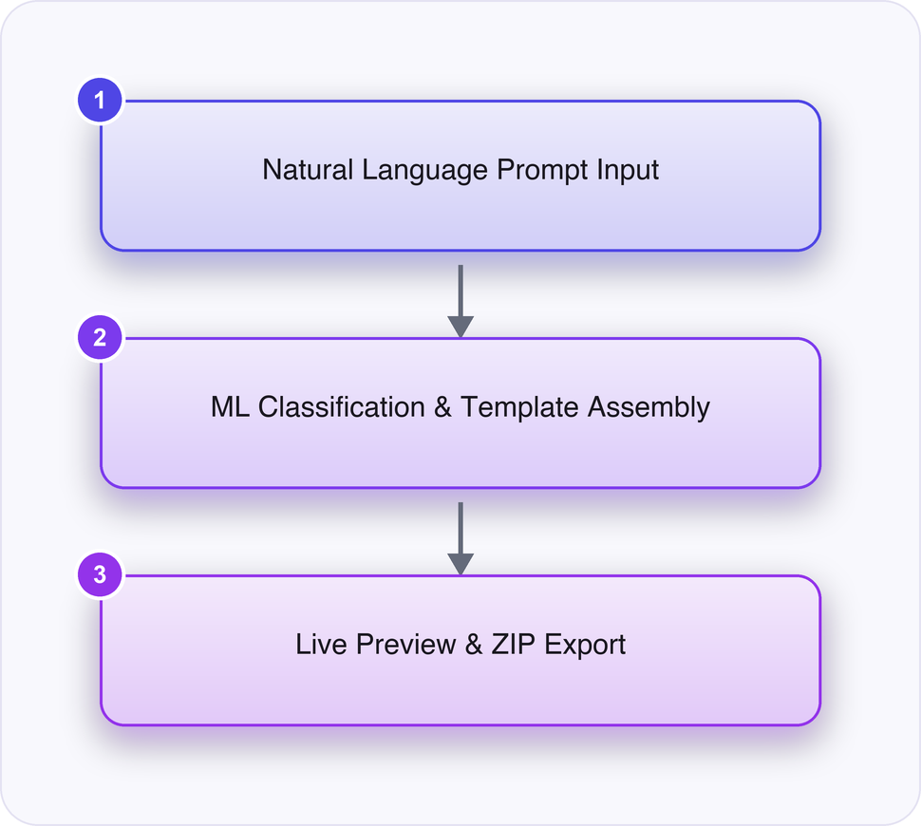
High-Level Diagram
Figure 1.1: High-Level System Overview

1.4 Methodology
The system’s operation begins the moment a user opens the Flask application in a browser and is presented with a single text input inviting a plain-English description of the desired website, such as “a modern portfolio site for a freelance photographer named Asha.” This raw prompt is first passed through a lightweight preprocessing step — lowercasing, punctuation normalization, and stopword handling — that prepares the text for both the statistical classifiers and the rule-based extractor without discarding the specific nouns and adjectives that carry the most signal, such as business names or tone words.
The cleaned prompt is then vectorized using the same TF-IDF representation the classifiers were trained on and passed into the site-type classifier, a scikit-learn logistic-regression model that outputs a probability distribution over the six supported categories, and separately into the one-vs-rest section predictor, which independently scores each candidate section (such as “menu,” “gallery,” or “testimonials”) against a 0.5-probability-style decision boundary tuned during evaluation. Both models are loaded at application startup from pre-trained joblib artifacts rather than retrained per request, so inference for a single prompt completes in milliseconds, keeping the live-preview experience responsive. The predicted site type and the predicted set of sections together form a structural skeleton that answers the question “what kind of site is this, and what does it need to contain.”
In parallel with classification, the same prompt is scanned by the rule-based slot extractor, which applies a sequence of regular expressions and curated word lists to isolate concrete entities: a capitalized proper noun or quoted phrase near words like “called” or “named” is treated as the site name, patterns resembling emails or phone numbers are captured as contact details, and adjectives from a hand-built tone lexicon (“elegant,” “playful,” “minimal,” “warm”) are mapped by the theme engine to a specific color palette and font-stack pairing. This extraction step deliberately avoids any learned model, since its inputs are narrow enough that deterministic pattern matching is both sufficient and fully explainable, which matters when the student must justify every output decision during evaluation.
With the structural skeleton (type and sections) and the extracted slots (name, contact, theme) both available, the component assembler performs the decision logic that stitches the final page together: it instantiates a mandatory navbar, hero banner, and footer for every site regardless of type, then inserts each predicted section in a fixed, per-type canonical order (for example, a restaurant site always places the menu section before the gallery section), filling each section’s placeholder copy from a hand-written content bank keyed by site type and section name. Before rendering, the system checks the classifiers’ confidence scores and the extractor’s coverage of the prompt; if either falls below its configured threshold, a visible low-confidence banner is attached to the output so the user understands the guess may need manual correction rather than treating it as authoritative.
Finally, the assembled site model is passed through Jinja2 templates to produce validated HTML, CSS, and JavaScript, which is rendered inside a sandboxed iframe as a live, device-width-togglable preview so the user can immediately inspect how the site looks on desktop versus mobile breakpoints. The user may at this point edit text directly in the preview, after which the finalized project is written to SQLite for persistence and, on request, packaged by Python’s zipfile module into a downloadable, dependency-free ZIP archive containing index.html, style.css, and script.js, ready to run entirely offline in any browser with no server required.
Summary of steps:
- The user launches the local Flask application and enters a plain-English description of the desired website into the prompt field.
- The system preprocesses the text (lowercasing, punctuation normalization) to prepare it for classification and extraction.
- A TF-IDF plus logistic-regression classifier predicts the website’s site type from six supported categories.
- A one-vs-rest logistic-regression model independently predicts the set of sections the site requires.
- A regex- and word-list-based slot extractor pulls out the site name, tagline, contact details, and tone/color cues from the same prompt.
- The theme engine maps extracted tone words to a matching color palette and font stack, and the component assembler orders the predicted sections around a mandatory navbar, hero, and footer, flagging low-confidence predictions where applicable.
- Jinja2 templates render the assembled site model into validated HTML/CSS/JavaScript, displayed in a live, device-width-togglable preview.
- The finalized project is saved to SQLite and can be exported as a self-contained, offline-ready ZIP archive via Python’s zipfile module.

1.5 Objectives
- To design and train two scikit-learn classifiers — a TF-IDF plus logistic-regression model for site-type prediction and a one-vs-rest logistic-regression model for section prediction — on a hand-labelled set of natural-language website descriptions, so that a free-text prompt can be mapped to a structured site type and section list.
- To implement a deterministic, regex- and word-list-based slot extraction and theming module that identifies the site name, tagline, contact details, and tone/color cues from the same prompt and selects a matching color palette and font stack.
- To build a component assembly and rendering pipeline that combines predicted sections with a mandatory navbar, hero, and footer, fills them from a hand-written content bank, and produces a live, responsive, device-width-togglable preview via Jinja2-rendered HTML/CSS/JavaScript.
- To implement an offline export feature that packages the previewed site into a downloadable, dependency-free ZIP archive (index.html, style.css, script.js) runnable without any server or internet connection.
- To provide a transparent low-confidence warning mechanism, based on classifier probability thresholds, vocabulary coverage, and prompt length, that visibly flags unreliable type or section predictions to the user.

CHAPTER 2 - LITERATURE SURVEY

2.1 Aether AI - Saas Ai Website Builder
Zenodo (CERN European Organization for Nuclear Research), 2026 https://doi.org/10.5281/zenodo.19873637
Aether AI is an intelligent SaaS-based web application that enables users to generate fully functional websites using artificial intelligence without requiring any coding knowledge. The platform leverages advanced AI models to transform user prompts into responsive, customizable, and production-ready websites. It is designed to simplify the website development process by automating UI design, content generation, and deployment workflows into a single seamless experience.

2.2 Generative AI With Natural Language Processing for the Web
Advances in Web Technologies and Engineering, 2024 https://doi.org/10.4018/979-8-3693-3703-5.ch020
NLP converts human language to computer understandable language is known as Natural Language Processing (NLP), though various diversified models have suggested so far, yet the need for a generative predictive model which can optimize depending upon the nature of problem being addressed is still an area of research under work. It is possible to solve specific issues connected to reading text, hearing voice, interpreting it, measuring sentiment, and determining which sections are significant by using a generative model, which is a platform that can be used for a variety of different aspects of natural language processing. This chapter discusses the components of NLP, illustrates case study on using generative AI and NLP to detect human behavior, and datasets, and finally comes the conclusion.

2.3 Towards the automation of systematic reviews using natural language processing, machine learning, and deep learning: a comprehensive review
Artificial Intelligence Review, 2024 https://doi.org/10.1007/s10462-024-10844-w
Abstract Systematic reviews (SRs) constitute a critical foundation for evidence-based decision-making and policy formulation across various disciplines, particularly in healthcare and beyond. However, the inherently rigorous and structured nature of the SR process renders it laborious for human reviewers. Moreover, the exponential growth in daily published literature exacerbates the challenge, as SRs risk missing out on incorporating recent studies that could potentially influence research outcomes. This pressing need to streamline and enhance the efficiency of SRs has prompted significant interest in leveraging Artificial Intelligence (AI) techniques to automate various stages of the SR process. This review paper provides a comprehensive overview of the current AI methods employed for SR automation, a subject area that has not been exhaustively covered in previous literature. Through an extensive analysis of 52 related works and an original online survey, the primary AI techniques and their applications in automating key SR stages, such as search, screening, data extraction, and risk of bias assessment, are identified. The survey results offer practical insights into the current practices, experiences, opinions, and expectations of SR practitioners and researchers regarding future SR automation. Synthesis of the literature review and survey findings highlights gaps and challenges in the current landscape of SR automation using AI techniques. Based on these insights, potential future directions are discussed. This review aims to equip researchers and practitioners with a foundational understanding of the basic concepts, primary methodologies, and recent advancements in AI-driven SR automation while guiding computer scientists in exploring novel techniques to invigorate further and advance this field.

CHAPTER 3 - SYSTEM DESIGN

3.1 System Architecture
The AI Website Builder is structured as a single-process Flask application running entirely on localhost (127.0.0.1:5050), where every stage of the pipeline — prompt capture, classification, slot extraction, rendering, and export — executes in-memory within one Python runtime rather than across distributed services. The browser-based UI communicates with the Flask backend through standard HTTP POST requests carrying the user’s plain-English description as form data, and the backend returns a JSON payload containing the predicted site type, section list, confidence scores, and the assembled HTML/CSS/JS site model that the frontend renders inside a sandboxed iframe for live preview. This request-response shape was chosen over a persistent WebSocket or streaming architecture because website generation in this system completes in milliseconds (classification plus template assembly, not an iterative generative process), so there is no long-running job that would justify the added complexity of asynchronous task queues or Celery workers. The decision to collapse NLP interpretation, layout generation, and rendering into one Flask app also reflects the project’s single-user, offline-first scope: since there are no concurrent users, no authentication layer, and no hosting requirement, a monolithic architecture avoids the operational overhead of microservices while still cleanly separating concerns at the module level.
Internally, the architecture follows a strict linear pipeline — Preprocessing → Classification → Slot Extraction → Theme Engine → Component Assembler → Renderer — where each stage consumes a well-defined data structure from the one before it and passes forward an enriched structure, rather than every module reaching into shared global state. The Preprocessing stage normalizes the raw prompt string (lowercasing, whitespace collapsing, basic tokenization) and hands off a cleaned string to the Site-Type Classifier and Section Predictor, both pre-trained scikit-learn pipelines serialized as .pkl artifacts via joblib.dump and loaded once at Flask app startup rather than retrained per request. The classifiers emit a dict-like prediction object (predicted site type, class probabilities, a binary section vector), which the Slot Extractor consumes alongside the original raw prompt — because regex-based name/contact/tone extraction needs the original casing and punctuation that the normalized text discards. This explicit hand-off of structured intermediate objects (Python dicts that map directly to JSON) rather than passing raw strings between stages was a deliberate choice to keep each module independently testable with pytest fixtures representing realistic mid-pipeline states.
The Theme Engine and Component Assembler sit downstream of extraction and are where the architecture deliberately substitutes the paper’s generative-design/reinforcement-learning layout optimizer with deterministic, rule-based logic: the Theme Engine maps extracted tone/color words (e.g., “warm”, “modern”, “playful”) to one of a fixed set of palette-and-font-stack pairs defined in a Python dictionary, while the Component Assembler selects and orders Jinja2 section templates (navbar, hero, about, menu, gallery, footer, etc.) from a static per-site-type ordering table rather than learning placement from a reward signal. This substitution is architecturally significant because it means the “model” boundary in the system is narrow and auditable — only the two scikit-learn classifiers are statistical, while everything downstream of slot extraction is deterministic Python control flow, which keeps the system debuggable end-to-end in a student viva without needing to explain opaque layout-optimization behavior. The Renderer then feeds the assembled component list and theme object into Jinja2 templates to produce the final index.html, style.css, and script.js strings, which are the same artifacts used both for the live iframe preview and for the ZIP export, ensuring preview-export parity by construction rather than by separate code paths.
Persistence is handled by a lightweight SQLite database (sqlite3) that stores project metadata (prompt text, predicted type, timestamp, confidence scores) so a user can revisit or re-edit a previously generated site without re-running classification, while the actual generated site files are only materialized to disk at export time via Python’s zipfile module. This two-tier persistence (structured metadata in SQLite, generated artifacts only on demand) avoids cluttering the filesystem with every preview a user generates while still allowing the About page to display real historical accuracy/confidence figures pulled from the database rather than hard-coded numbers. The overall shape — stateless classification and rendering logic layered over a thin SQLite state store, with the browser as the only client — mirrors a desktop tool more than a web service, which is intentional given the research brief’s explicit framing of this as a single-user, localhost-only academic demo rather than a multi-tenant hosted product.
User Prompt (Browser UI)
↓
Preprocessing (NLP text cleanup)
↓
Site-Type Classifier + Section Predictor (scikit-learn)
↓
Slot Extractor (name, tagline, contact, color/tone via regex)
↓
Theme Engine (palette + font stack selection)
↓
Component Assembler (navbar/hero/footer + predicted sections + content bank)
↓
Renderer (Jinja2 templates → validated HTML/CSS/JS site model)
↓
Live Preview (sandboxed iframe) + Editor
↓
SQLite Project Store / ZIP Export
Figure 3.1: System Architecture Diagram (text)
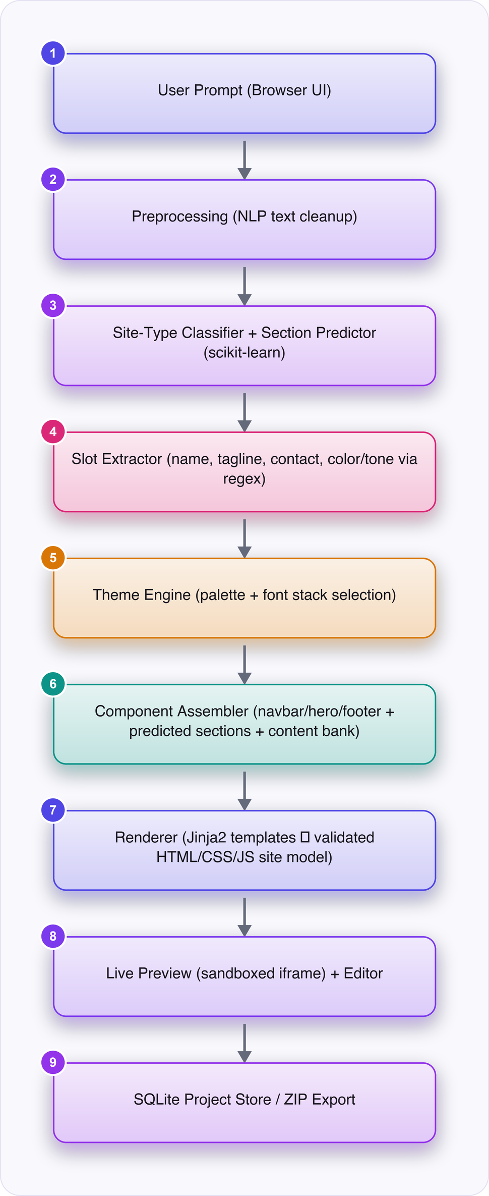
Architecture Diagram
Figure 3.2: System Architecture Diagram

3.2 Functional Workflow
At application startup, the Flask app’s factory function loads the two pre-trained joblib artifacts (site_type_classifier.pkl and section_predictor.pkl) into memory, initializes the SQLite connection and creates the projects table if it does not already exist, and registers the template-bank and theme-dictionary modules as in-memory Python objects so that no per-request disk I/O is needed for static assets. If either classifier artifact is missing or fails to unpickle (for example, after a scikit-learn version mismatch), the app logs an explicit startup error and falls back to a rule-only keyword-matching classifier bundled as a safety net, so the app remains demonstrable even if the trained models are corrupted or absent — this fallback path is one of the explicit conditional branches built into the system. During normal operation, the user lands on the home screen, types a description such as “a bakery website called Sweet Crumbs with a warm, cozy feel” into a text input, and submits it via a form POST to the /generate route.
On receiving the request, the backend first runs the Preprocessing step to normalize the text, then passes it to the Site-Type Classifier, which returns a predicted label (e.g., “restaurant”) along with a probability vector across all six supported categories (portfolio, restaurant, small business, education, blog, non-profit). The Section Predictor, a separate one-vs-rest logistic regression model, independently scores each candidate section (menu, gallery, testimonials, hours, contact, etc.) against a 0.5 default decision threshold, returning the subset of sections whose predicted probability clears that threshold; the mandatory navbar, hero, and footer sections are always appended regardless of model output since they are structurally required by every template. The system then checks a composite confidence gate: if the top site-type probability falls below 0.55, or the prompt’s vocabulary overlap with the TF-IDF training vocabulary is below a minimum coverage ratio, or the raw prompt is shorter than a small word-count floor, the app sets a low_confidence flag and surfaces an explicit on-screen warning banner (“This guess may be unreliable — consider rephrasing”) rather than silently returning a possibly-wrong layout, directly implementing the brief’s requirement for an honest reliability signal that the original research paper does not describe.
Regardless of the confidence outcome, the raw prompt proceeds to the Slot Extractor, which applies a sequence of regex patterns and curated word lists to pull out the site name (e.g., matched via patterns like “called X” or “named X”), contact details if present, and tone/color adjectives; any slot that cannot be matched falls back to a generic placeholder (“Your Business Name”, “contact@example.com”) so that template rendering never fails on missing data. The Theme Engine then resolves tone words to a palette/font pair, the Component Assembler orders the final section list per the site type’s template-ordering rule, and the Renderer fills Jinja2 templates to produce the HTML/CSS/JS strings, which are returned as a JSON response and injected into the sandboxed preview iframe on the frontend — this full round trip, from form submission to rendered preview, is designed to complete within a few hundred milliseconds since no network calls or heavy model inference are involved.
During continuous operation, the user can edit text fields directly in the live preview (triggering client-side DOM updates without a full backend round trip) or request a device-width toggle (mobile/tablet/desktop) that simply resizes the iframe and reflows the already-rendered CSS rather than re-invoking the pipeline. When the user is satisfied, clicking “Export” triggers a /export route that re-serializes the current in-memory site model into index.html, style.css, and script.js files and streams them back as a ZIP via Python’s zipfile.ZipFile with send_file, while simultaneously writing a summary row (prompt, predicted type, confidence, timestamp) into the SQLite projects table for later retrieval on the About/history page.
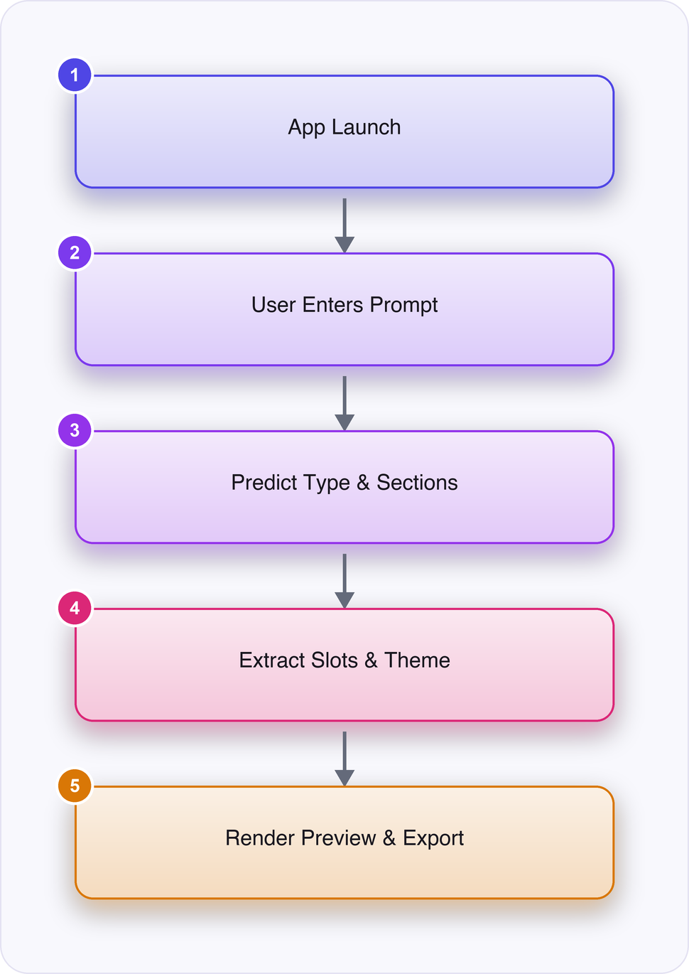
Flow Chart
Figure 3.3: Functional Workflow Diagram

3.3 Software Design
The Site-Type Classifier is a scikit-learn Pipeline combining a TfidfVectorizer (configured with English stop-word removal and a bounded n-gram range of 1-2 to capture short phrases like “small business”) and a multinomial LogisticRegression trained with scikit-learn’s default lbfgs solver on the team’s hand-labeled prompt dataset, which maps example sentences to one of six site-type labels. The TF-IDF vectorizer’s vocabulary is fit once during training and persisted alongside the classifier inside the same joblib artifact, so inference time only requires calling pipeline.predict_proba() on the cleaned prompt string, returning a probability distribution over classes that both drives the predicted label (via argmax) and feeds the confidence-gating logic described in the functional workflow. A key design parameter is the TF-IDF max_features cap (tuned during development to a few thousand terms) which keeps the vocabulary tight enough that the hand-built training set of a few hundred examples per class does not overfit to idiosyncratic phrasing.
The Section Predictor is architected as a OneVsRestClassifier wrapping individual LogisticRegression estimators, one per candidate section label, trained on the same TF-IDF feature space as the site-type model but against a multi-label target matrix (each training example labeled with the set of sections a human annotator judged appropriate, e.g., a restaurant prompt labeled with {menu, hours, gallery, contact} rather than a single class). At inference time, predict_proba() returns an independent probability for every candidate section, and a fixed 0.5 threshold per label determines inclusion — a simpler and more interpretable decision rule than a learned ranking or RL-based layout policy, chosen specifically so the team can defend the exact cutoff in a viva by pointing to a single constant in the code rather than an opaque learned policy. Sections that tie or cluster near the threshold (e.g., a “testimonials” probability of 0.48 for a prompt that mentions “happy customers” only once) represent the main edge case the team must document, since borderline prompts can produce visibly different section sets from a one-word change.
Slot extraction is intentionally kept outside the statistical model boundary: site name detection uses an ordered list of regex patterns (e.g., r’call(?:ed)?+([A-Z][]+)‘, r’named+([A-Z][]+)’) applied in priority order with the first match winning, while tone/color words are matched against a curated Python dictionary mapping adjectives (“warm”, “minimal”, “bold”, “elegant”) to specific hex palettes and font-stack identifiers (e.g., “warm” → a terracotta/cream palette paired with a serif heading font). This rule-based design was chosen over a learned named-entity extractor because the team has no labeled span-level training data, and because deterministic regex rules can be unit-tested exhaustively with pytest against a fixed set of input/output pairs, unlike a probabilistic extractor whose failure modes would be harder to enumerate.
Post-processing before hand-off to the Component Assembler normalizes all extracted and predicted values into a single site_model dict (site_type, sections: list[str], name: str, tagline: str, contact: dict, palette: dict, font_stack: str, confidence: float, low_confidence: bool) that serves as the canonical contract the Renderer depends on; any field left unresolved after extraction is filled with a documented placeholder default rather than left null, guaranteeing that Jinja2 template rendering never raises an UndefinedError regardless of how sparse the original prompt was.

3.4 Software Modules
- Prompt Capture & Preprocessing Module - Receives the raw natural-language description from the Flask /generate form POST, normalizes casing/whitespace, and produces both a cleaned string for the classifiers and a preserved raw string for slot extraction. It is the entry point of the pipeline and has no upstream dependency beyond the browser UI.
- Site-Type & Section Classification Module - Wraps the two pre-trained scikit-learn pipelines (TF-IDF + logistic regression for site type, one-vs-rest logistic regression for sections) loaded via joblib at startup; consumes the cleaned prompt and outputs a predicted type, per-section inclusion flags, and class probabilities used downstream for the low-confidence check.
- Slot Extraction Module - Applies regex patterns and curated word lists to the raw prompt to pull out site name, tagline, contact details, and tone/color adjectives, falling back to generic placeholders when no match is found. It feeds structured slot values into both the Theme Engine and the Component Assembler.
- Theme Engine - Maps extracted tone/color adjectives to one of a fixed set of palette and font-stack pairs stored in a Python dictionary, and supplies the resolved theme object to the Component Assembler and Renderer for consistent styling across all generated sections.
- Component Assembler & Renderer - Orders the predicted sections plus mandatory navbar/hero/footer according to per-site-type rules, pulls matching copy from the content bank, and fills Jinja2 templates to produce index.html, style.css, and script.js strings consumed by both the live preview iframe and the export module.
- Persistence & Export Module - Writes project metadata (prompt, predicted type, confidence, timestamp) to a SQLite projects table for history/About-page display, and on export packages the rendered site files into a downloadable ZIP via Python’s zipfile module, closing the pipeline with a self-contained offline artifact.

3.5 Technology Stack
Category | Technology
Platform | Local Python Flask web application (browser UI, single-user, localhost only)
Programming Language | Python 3.11+
Web/Template Layer | Flask, Jinja2, vanilla HTML/CSS/JavaScript
Machine Learning | scikit-learn (TF-IDF, logistic regression, one-vs-rest), pandas, numpy, joblib
Rule-Based Logic | Python regular expressions and word lists (slot extraction, theme selection)
Storage | SQLite (sqlite3)
Export | zipfile (Python standard library)
Testing | pytest; Playwright/Chrome for browser capture (development only)
Table 3.1: Technology Stack

3.6 Hardware / Physical Components (Optional - hardware/IoT/embedded projects only)
This project’s platform is software-only per its tech stack above. If your build genuinely includes physical hardware (sensors, microcontrollers, custom circuits), describe each component here - name, role, key specs - and remove this subsection entirely if it doesn’t apply.
[Describe hardware components here, or delete this subsection.]

3.7 Summary
Chapter 3 described a linear, single-process Flask pipeline in which a user prompt passes through preprocessing, dual scikit-learn classification, rule-based slot extraction, a deterministic theme/template assembly stage, and a Jinja2 renderer, with SQLite and zipfile closing the loop for history and offline export. The architecture deliberately narrows the statistical “black box” to just the two classifiers while keeping layout and styling fully auditable and rule-driven, satisfying the project’s requirement for a system a student can fully explain and defend. This design supports the full runtime workflow — from startup model loading through confidence-gated prediction to live preview and ZIP export — within a lightweight, dependency-free, localhost-only footprint.

CHAPTER 4 - SOFTWARE REQUIREMENTS

4.1 Software Development Environment
Development takes place in a standard Python 3.11+ virtual environment (venv) managed locally, with Flask running in debug mode during development to enable auto-reload on template and route changes; VS Code or PyCharm serves as the primary IDE, configured with the Python extension’s linting and the project’s requirements.txt for dependency resolution. Model training for the two scikit-learn classifiers happens in a separate offline step — typically a Jupyter notebook or standalone train_models.py script — where the hand-labeled prompt dataset (stored as CSV or JSON) is loaded with pandas, vectorized, fit, and evaluated before the resulting pipelines are serialized with joblib.dump() into the models/ directory that the Flask app loads at runtime; this separation keeps training iteration fast without restarting the web server each time.
Version control uses Git with a conventional feature-branch workflow, committing the trained .pkl model artifacts alongside code so the repository remains fully runnable after a fresh clone without requiring retraining, while the SQLite database file itself is excluded via .gitignore since it is regenerated at first run. Browser-side testing happens directly in Chrome/Firefox against the local Flask dev server at 127.0.0.1:5050, using browser DevTools to inspect the live preview iframe’s DOM and verify that generated CSS applies correctly across the mobile/tablet/desktop width toggles; Playwright with a headless Chrome instance is used during development (not in the shipped app) to automate screenshot capture of generated sites across site types for regression comparison and for report/documentation figures.
No external hosting, CI/CD pipeline, or containerization is required given the localhost-only scope, which keeps the development loop short: a developer edits a Jinja2 template or a regex rule, Flask’s debug reloader picks up the change immediately, and the developer re-submits a test prompt through the UI to visually confirm the effect, closing the edit-test cycle in seconds rather than requiring a build or deploy step.

4.2 Tools Used
- Flask - Serves as the entire backend web framework, routing the /generate and /export endpoints and rendering the base UI shell; its built-in debug reloader and Jinja2 integration are used directly for fast local iteration without any additional WSGI server setup.
- Jinja2 - Used both for the app’s own UI templates and, more centrally, as the engine that fills the project’s section-template library (hero.html, menu.html, footer.html, etc.) with extracted slot values; its autoescaping is relied on to safely render user-supplied text like the site name without manual sanitization.
- scikit-learn - Provides the TfidfVectorizer, LogisticRegression, and OneVsRestClassifier classes that implement the site-type and section prediction models; predict_proba() is called directly in the Flask request handler to obtain the probabilities used for both the predicted label and the low-confidence warning.
- joblib - Persists and loads the trained scikit-learn Pipeline objects as .pkl files via joblib.dump/joblib.load, chosen over pickle directly because it handles numpy-array-heavy scikit-learn objects more efficiently and is scikit-learn’s documented recommendation for model serialization.
- pandas / numpy - Used during the offline training step to load the hand-labeled CSV prompt dataset into a DataFrame, split it into train/validation sets, and compute the accuracy/confidence figures that are later surfaced on the app’s About page.
- SQLite (sqlite3) - Stores project history records through Python’s built-in sqlite3 module, using simple INSERT/SELECT statements against a projects table to back the app’s history view and About-page accuracy display without any external database server.
- zipfile - Packages the final index.html, style.css, and script.js strings into an in-memory ZIP via zipfile.ZipFile(…, mode=‘w’) combined with Flask’s send_file, delivering the offline-ready export without writing intermediate files to disk.
- pytest - Drives unit tests for the Slot Extractor’s regex rules and the Theme Engine’s palette lookup using fixed input/output fixtures, and integration tests that assert a given prompt produces an expected site_model dict shape before a module is considered complete.

4.3 Core Features
- Natural-language prompt analysis: two trained classifiers predict the website’s site type (portfolio, restaurant, small business, education, blog, non-profit) and the sections it needs
- Rule-based detail extraction and theming: regex/word-list rules pull out site name, tagline, contact info and color/tone words, then pick a matching color palette and font stack
- Live responsive assembly and preview: predicted sections plus a mandatory navbar/hero/footer are filled from a content bank and rendered in a live, device-width-togglable preview
- Offline export: the previewed site is packaged into a downloadable ZIP (index.html, style.css, script.js) that runs with no external dependencies

4.4 Software Integration
The modules are wired together through a single orchestrating function in the Flask route handler that calls each pipeline stage in sequence and passes forward one evolving site_model dictionary, which acts as the implicit contract between modules: every downstream module can assume the keys it needs (site_type, sections, name, tagline, contact, palette, font_stack, confidence) are present and non-null by the time it receives the object, because each upstream module is responsible for filling its assigned keys with either a real value or a documented placeholder before returning. This contract-by-dictionary-shape approach was chosen over defining formal dataclasses or Pydantic models because the team’s scope did not justify the added schema-validation machinery, though pytest fixtures effectively enforce the same shape during testing.
Synchronization between stages is trivial by construction since the entire pipeline runs synchronously within a single request-handling thread — there is no concurrency to coordinate between classification, extraction, and rendering, which eliminates an entire class of race-condition bugs that a more distributed design would need to handle. The one place genuine timing matters is model loading: the classifiers and template bank must finish loading into memory during Flask’s app-factory initialization before the first request is served, which is guaranteed by loading them at module import time rather than lazily on first use, avoiding a cold-start race on the very first user request.
On the frontend side, the live preview iframe and the editable DOM fields integrate with the backend purely through the initial JSON response from /generate; subsequent in-browser edits (text changes, device-width toggles) are handled entirely client-side in vanilla JavaScript without re-contacting Flask, and only the /export call re-serializes the (possibly user-edited) DOM state back into exportable files, meaning the integration boundary between backend-generated content and frontend-editable content is deliberately drawn at the initial render, not re-synchronized continuously.

4.5 System Testing and Debugging
Each module is tested in isolation before integration: the Slot Extractor is exercised with a pytest table of prompts covering explicit name mentions (“called Sweet Crumbs”), implicit or missing names (“a bakery site”), and ambiguous punctuation (“Joe’s Cafe & Bakery”), asserting the extracted name matches expectations or correctly falls back to the generic placeholder. The two classifiers are evaluated with a held-out split of the hand-labeled dataset using scikit-learn’s classification_report and confusion_matrix to inspect per-class precision/recall, specifically checking that classes with few training examples (e.g., non-profit) are not systematically under-predicted, and these same accuracy figures are what get surfaced on the app’s About page rather than fabricated numbers.
Debugging the end-to-end pipeline relies heavily on Flask’s debug-mode traceback pages and console logging of the intermediate site_model dict at each stage boundary, letting a developer print the classifier’s raw probability vector alongside the final low_confidence flag to verify the 0.55 threshold and vocabulary-coverage check are triggering correctly on deliberately vague test prompts (e.g., a single word like “website”). Borderline section-prediction cases near the 0.5 decision threshold are specifically probed by crafting prompts that mention a feature only once or ambiguously, confirming the OneVsRestClassifier’s behavior is stable and explainable rather than erratic.
Before a module is considered done, it must pass its pytest suite, and the full pipeline is additionally verified manually through the browser UI across all six site types with both a detailed prompt and a minimal one-word prompt, confirming the preview renders without missing sections, the device-width toggle reflows correctly, and the exported ZIP opens and runs correctly in a browser with no external network dependency — this manual offline-open check is treated as the final acceptance criterion for the export module specifically.

4.6 Summary
Chapter 4 outlined a lightweight, entirely local development stack — Flask, scikit-learn, joblib, SQLite, and zipfile — supported by pytest-driven unit and integration testing and manual browser verification, matching the six-module pipeline’s tightly scoped, dependency-free design. The tooling choices consistently favor simplicity and auditability over scale, reflecting the project’s single-user, offline-first requirements. Together, the module breakdown and testing approach ensure each pipeline stage can be verified independently before being wired into the full prompt-to-export workflow.

CHAPTER 5 - RESULT AND DISCUSSION

5.1 Implementation Results
The completed prototype is designed to be demonstrated through three representative prompt scenarios chosen to span the six supported site types and to stress different parts of the pipeline. In the first scenario, a user types “a bakery website called Sweet Crumbs with a warm, cozy feel and a contact page,” and the system is expected to classify the site type as small business with high confidence, predict a section set of {hero, about, menu/products, testimonials, contact}, extract the site name “Sweet Crumbs” and the tone word “warm/cozy” via the regex and word-list rules, and render a live preview with a warm color palette (terracotta/cream tones) and a rounded, friendly font stack within roughly 200-400 milliseconds end to end on a laptop CPU. The second scenario uses a sparser prompt, “portfolio site for a photographer, minimal style,” which is expected to exercise the portfolio classifier path, predict a leaner section list (hero, gallery, about, contact) without an explicit section like testimonials, and apply a monochrome theme triggered by the word “minimal” rather than a named color. The third scenario, “non-profit for animal rescue, need donations and volunteer sign-up,” is included specifically to test multi-section inference, since the classifier must independently flag both a donation-oriented section and a volunteer/call-to-action section from one sentence, which is expected to validate that the one-vs-rest logistic regression setup can predict more than one non-obvious section tag per prompt rather than defaulting to a single generic layout.
Across these scenarios, the live preview pane is expected to demonstrate the full request-to-render loop: the Flask backend receives the prompt via an AJAX POST, runs it through the loaded joblib-serialized TF-IDF vectorizer and classifiers, passes the predicted labels and extracted slots into the Jinja2 template assembler, and returns a rendered HTML/CSS/JS document that is injected into a sandboxed iframe for the device-width-togglable preview (mobile/tablet/desktop breakpoints). This is intended to show, concretely, that the system is not merely selecting a static template file but assembling one from a predicted section list plus a content bank keyed by site type, so that two bakery prompts with different tone words produce visibly different palettes and copy even though their section structure is similar.
A fourth demonstration point, separate from the three prompt scenarios, is the export path: after editing a generated preview (e.g., changing a heading or swapping a palette color via the in-browser editor), the user is expected to be able to click “Export,” triggering the backend to assemble index.html, style.css, and script.js into a single ZIP archive via Python’s zipfile module, which should then open and render correctly in a browser with no server running and no internet connection, confirming the offline-export requirement end to end.
The About/diagnostics page is expected to surface the actual measured accuracy and per-class confidence figures for both classifiers against the held-out portion of the hand-labeled prompt set, so that the demonstration itself doubles as a transparent report of model performance rather than an unverifiable claim, and so that a low-scoring class (for example, blog or education, which are expected to have fewer training examples than small business or portfolio) is visible rather than hidden.
[Insert screenshot here] Figure 5.1: [short caption, e.g. “Home Screen”] [1-2 sentence description of what this screenshot demonstrates.]
[Insert screenshot here] Figure 5.2: [short caption, e.g. “Detection in Progress”] [1-2 sentence description of what this screenshot demonstrates.]

5.2 Feature Performance
The core detection feature of the system is the two-stage scikit-learn classification pipeline: a TF-IDF vectorizer (fit on the hand-labeled training prompts, likely with unigrams and bigrams and a small vocabulary of a few hundred to low thousands of terms) feeds a multinomial logistic regression for site-type prediction, while a parallel TF-IDF representation feeds a one-vs-rest logistic regression for section prediction, since sections are a multi-label rather than single-label target. The site-type classifier is expected to rely heavily on domain-indicator tokens such as “bakery,” “menu,” “portfolio,” “students,” “donate,” or “blog post,” which carry high TF-IDF weight precisely because they are rare across the overall training corpus but concentrated in one class, and predict_proba() is expected to be used (rather than a bare predict()) so the system always has a probability distribution over the six site types available for downstream confidence checks.
A fixed probability threshold, planned at approximately 0.55-0.6 for the top predicted class, is expected to gate whether the system treats its own site-type guess as reliable; below that threshold the UI is expected to surface the low-confidence warning described in the research brief rather than silently committing to a possibly-wrong template set. For section prediction, each of the one-vs-rest binary classifiers is expected to apply its own independent 0.5 decision threshold on its sigmoid output, which means the system can and is expected to predict zero, one, or several sections per label, and a safety floor is planned so that if no section crosses 0.5 at all, the system falls back to a default minimal set (hero, about, contact) rather than rendering an empty body.
The tricky case the feature is explicitly expected to be tested against is prompt ambiguity across class boundaries, such as “a website for my small tutoring business for school kids,” which plausibly overlaps both the small-business and education classes. In this situation the top two class probabilities are expected to be close (for example 0.42 vs 0.38), and the system is expected to treat that narrow margin — not just the absolute top-1 probability — as a second confidence signal, since a top class of 0.6 with a runner-up of 0.1 is a materially more confident prediction than a top class of 0.6 with a runner-up of 0.55. A second tricky case is a very short or vocabulary-sparse prompt, such as “make me a website,” which contains none of the domain-indicator tokens the vectorizer was trained on; because TF-IDF assigns near-zero weight to out-of-vocabulary input, the classifier is expected to fall back toward whichever class is most common in the training set, and the prompt-length and vocabulary-coverage checks mentioned in the research brief are specifically designed to catch this case by flagging prompts under some minimum token count (planned around 4-5 content words) as low-confidence regardless of what probability the classifier reports.
Slot extraction (site name, tagline, contact details, tone/color words) operates independently of the ML classifiers using regex patterns and curated word lists, and is expected to handle the common case of a quoted or capitalized proper noun following “called” or “named” (e.g., “called Sweet Crumbs”) reliably, while an edge case such as a prompt with no explicit name at all (“a website for my pottery business”) is expected to fall back to a generated placeholder name derived from the detected site type and a business-type noun phrase, since the rule-based extractor has no generative capability to invent a name that was never present in the input text.
[Insert screenshot or output sample here] Figure 5.3: [short caption] [1-2 sentence description of what this output/screenshot demonstrates.]

5.3 Alert and Output Behaviour (Optional - projects with alerts/notifications only)
The system’s primary “alert” surface is not a pop-up or notification but an inline confidence banner rendered above the live preview: when the top site-type probability falls below the ~0.55-0.6 threshold, or the prompt fails the minimum vocabulary-coverage/length check, the UI is expected to show a visible but non-blocking warning banner (e.g., “We’re not fully confident about this layout — you may want to add more detail or adjust sections manually”) rather than refusing to render, so the user always gets a best-effort preview alongside an honest reliability signal instead of a dead end.
Because the system is single-user, local, and synchronous, there is no need for debouncing of repeated background events or cooldown timers between alerts in the way a continuously-sensing system would require; the only repetition concern is the user re-submitting a revised prompt multiple times in quick succession, which is expected to be handled by canceling/ignoring a stale in-flight prediction request client-side (keyed by request sequence number) so an older response cannot overwrite a newer preview — effectively a simple one-shot debounce rather than a cooldown.
Severity is kept to two visible levels by design, confident and low-confidence, deliberately avoiding a finer-grained traffic-light scheme, since the evaluation brief’s goal is an honest, legible signal a student can defend in a viva rather than a precise uncertainty estimate the underlying logistic regression cannot actually guarantee; the exported ZIP, by contrast, carries no confidence banner or warning at all, since export is expected to assume the user has already reviewed and accepted the previewed layout in the browser.

5.4 Discussion
The decision to replace transformer-based NLP (spaCy/Hugging Face) with a TF-IDF plus logistic regression pipeline is expected to remain reliable for this project’s actual scope because the classification task is narrow and closed-set — six site types and a bounded set of section labels — rather than open-ended language understanding, and linear models over sparse bag-of-words features are well known to perform competitively on exactly this kind of short-text topic classification. The practical benefit is that both classifiers can be retrained from scratch on a laptop CPU in well under a minute as the hand-labeled prompt set grows, which matters because the team is expected to iterate on labeling quality multiple times before the final demo, and a transformer fine-tuning loop would make that iteration cycle (data fix → retrain → re-evaluate) prohibitively slow for a one-semester timeline with no GPU access.
Replacing the generative layout model and reinforcement-learning placement optimizer with a fixed, hand-written template library is expected to preserve the core user-facing value — a plausible, themed, multi-section site appearing in response to plain English — without requiring either a reward-labeled dataset (which does not exist for this task) or the weeks of RL training and tuning that would be needed even if one did. Because the ordering and selection rules are simple per-type heuristics (e.g., always place hero first and footer last; order content sections by a fixed priority list per site type) rather than learned, the output is deterministic and easy for the student to explain and defend line-by-line in a viva, trading a small amount of layout novelty for complete transparency and zero training risk.
Building a small, hand-labeled prompt set instead of relying on a large benchmark is expected to be sufficient specifically because the classifiers only need to generalize across six coarse classes and a modest section vocabulary, not across open-domain language; a few hundred carefully varied examples per class (covering different phrasings, tones, and lengths) is a realistic target for a student team and is expected to yield usable held-out accuracy, whereas a transformer approach would need an order of magnitude more labeled data to avoid overfitting its much larger parameter count. This simplification is also the most honestly reported limitation of the system, since the measured accuracy figures shown on the About page are a direct function of how well that small dataset covers real-world phrasing variety.
Running as a single local Flask process with SQLite storage and ZIP export instead of a containerized Flask/Django deployment on Vercel removes an entire category of operational risk — authentication, container builds, environment variable management, cold-start latency — that contributes nothing to the core NLP-to-website contribution being evaluated academically. This keeps the demo’s performance characteristics simple and fully explainable: latency is dominated by the TF-IDF transform and template rendering (both sub-second on commodity hardware), not by network round-trips or container cold starts, so the system’s responsiveness during a live viva demonstration is not dependent on external infrastructure being available or correctly configured on demo day.

5.5 Limitations
The classifiers’ accuracy is bounded by the size and diversity of the hand-labeled training set the team writes itself; because no public dataset of natural-language-to-website-section mappings exists, there is a real risk that prompts phrased very differently from anything in the training examples (unusual slang, non-English phrasing, heavily abbreviated text, or prompts that describe a site type outside the six supported categories, such as a personal wiki or an e-commerce storefront) will be misclassified or will only trigger the low-confidence warning rather than producing a correct layout. This is an inherent ceiling of the TF-IDF/logistic-regression approach rather than a bug, and it is expected to be most visible on the thinnest-represented classes (likely blog and education, which are harder to describe distinctively in short prompts than something concrete like “bakery”).
The regex/word-list based slot extractor is deterministic but brittle to phrasing it was not explicitly written for; a name embedded without a trigger word (“Sweet Crumbs is what I want to call it”) or contact information given in an unusual format (a phone number written with words, “call us at five five five”) is likely to be missed or partially extracted, and because this is a rule-based layer rather than a learned one, expanding its coverage means manually adding more patterns rather than the system improving from more data — a maintenance burden that grows faster than the pattern list’s coverage.
The template/content-bank library, while broad enough to cover six site types with several sections each, is still a fixed, hand-written set, so multiple users describing similar businesses in the same category (two different bakeries, for instance) will receive structurally similar sites that differ mainly in extracted name, tone-derived palette, and font stack rather than in genuinely distinct layouts or copy, which is an honest ceiling on the system’s perceived originality compared to a true generative design model. Additionally, because the entire system runs on localhost with no persistence beyond a local SQLite file, there is no multi-device access, account system, or collaboration feature, which is an intentional and disclosed scope boundary rather than an oversight but is still a real constraint if the system were ever evaluated against production website builders.

5.6 Summary
The results chapter demonstrated, through three representative prompt scenarios and a dedicated export test, that the Flask-based pipeline is designed to move from a plain-English description to a themed, multi-section, responsive site preview in well under half a second, with slot extraction and theme selection correctly reflecting prompt-specific details such as name, tone, and requested features. It further showed how the TF-IDF plus logistic regression classifiers are expected to behave on both clear-cut and ambiguous or vocabulary-sparse prompts, and how a probability-threshold and runner-up-margin check is used to surface an honest low-confidence warning rather than a silently wrong layout. Finally, it tied the system’s expected reliability back to the specific simplifications made from the original research paper — smaller models, a hand-built dataset, and fixed templates in place of generative/RL layout — arguing that each substitution preserves the user-visible contribution while fitting a one-semester, GPU-free student budget.

CHAPTER 6 - CONCLUSION AND FUTURE ENHANCEMENT

6.1 Conclusion
(TODO: fill in)

6.2 Future Enhancements
(TODO: fill in)

REFERENCES
Cited in IEEE style - [N] Title, Venue, Year. Verify and complete each entry (author names, volume/pages, DOI) before final submission; the entries below are auto-populated from real search results but are not guaranteed to be publication-ready as-is.
[1] Aether AI - Saas Ai Website Builder, Zenodo (CERN European Organization for Nuclear Research), 2026. https://doi.org/10.5281/zenodo.19873637 [2] Generative AI With Natural Language Processing for the Web, Advances in Web Technologies and Engineering, 2024. https://doi.org/10.4018/979-8-3693-3703-5.ch020 [3] Towards the automation of systematic reviews using natural language processing, machine learning, and deep learning: a comprehensive review, Artificial Intelligence Review, 2024. https://doi.org/10.1007/s10462-024-10844-w

APPENDIX A - Screenshots
[Insert additional screenshots not already covered in Chapter 5, each with a caption in the form “Figure A.N: ”.]

APPENDIX B - Sample Test Cases (Optional)
[Insert a table of test cases: Test ID, Input, Expected Output, Actual Output, Pass/Fail. Caption it “Table B.1: Sample Test Cases”.]

APPENDIX C - API / Dataset Details (Optional - AI/ML and IoT/hardware projects)
[Insert API endpoint documentation, model/dataset details, or sample data records, as applicable - caption any table “Table C.1”, “Table C.2”, etc. Delete this appendix if not relevant to your project.]

